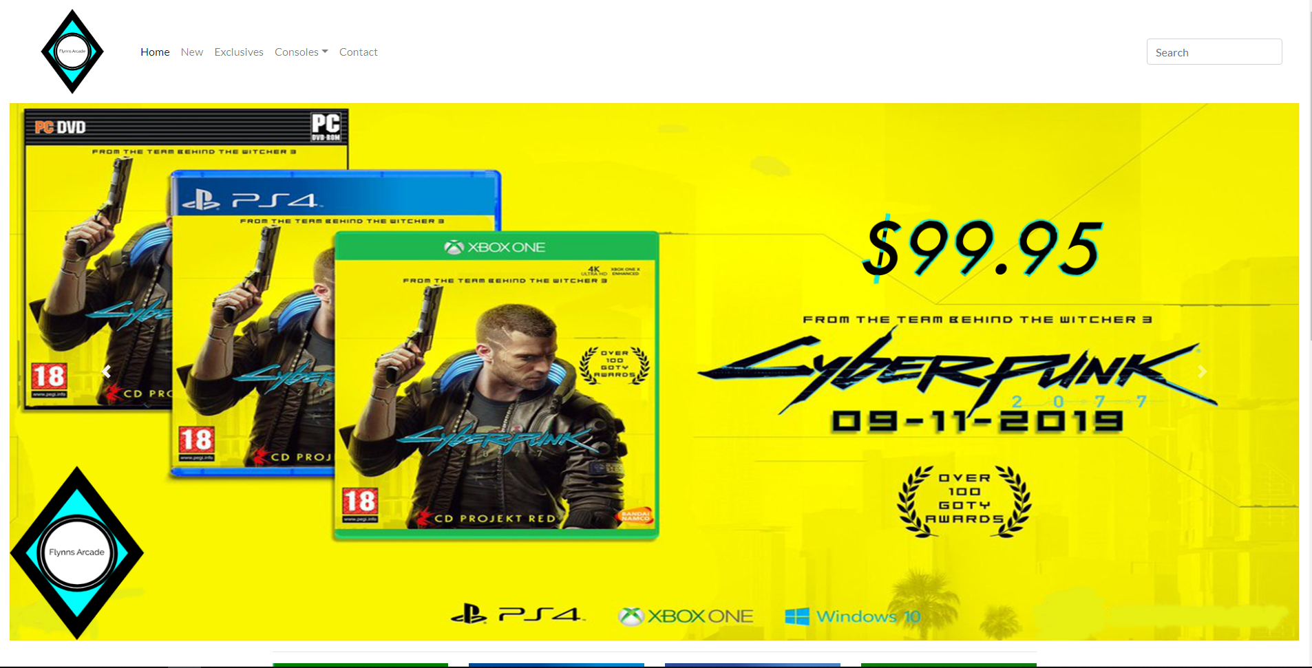

Flynn’s Portfolio

Shawn Reynolds | IST | 30/08/19

Contents

**Design Brief** 2

**Research** 3

**Design sketches** 4

**Final Concept design** 5

**Design changes** 6

**Evaluation** 7

**Bibliography** 8

# **Design Brief**

Flynn’s Arcade has been slowly losing money as the trend for accessing video games has moved away from social ‘video game arcades’ to at home ‘video game consoles such as the Atari and Commadore 64. Flynn wants to reposition his business as a venue for selling new games and trading used games. Flynn wants you to design and create ‘alpha phase’ website that communicates his new business model (More information on Flynn’s Arcade: <http://tron.wikia.com/wiki/Flynn’s_arcade>)

Criteria for success:

* Functioning menu.
* Contact information.
* Clear navigation.
* Social media.
* Location of nearby stores.

# **Area of Investigation**



Wix is an Israeli cloud based web development platform. It allows users to create HTML5 websites for desktop and mobile users with the use of drag and drop tools. Wix lets you do many things like selling an unlimited amount of products, physical, digital and services. Wix Is mostly free but some feature you will need to pay for if you want to use them.



Squarecpace is a private American company based in New York City. Squarespace provides softwares for website building and hosting. Squarespace’s users use pre-built website templates and drag and drop elements to create their websites. Squarespace costs anywhere from $12 to $40 a month.

# **Design sketches**

# **Final Concept design**

# **Design changes**

# **Evaluation**

# **Bibliography**